**EPH-International Journal of Medical and Health Science**

[ISSN (Online):](http://oapub.org/edu/index.php/ejes) 2208-2158

[Volume 09 Issue 02 April 20](http://oapub.org/edu/index.php/ejes)23

**DOI:**

EVALUATING PESTICIDE-INDUCED TOXICITY IN CYPRINUS CARPIO: CYHALOTHRIN AS A CASE STUDY

**Dr Umme Habeeba1*, Dr M David2**

*1*Assistant Professor, Government First Grade College, Rajnagar, Hubli, Karnataka*

*2Professor, Department of studies in Zoology, karnatak University, Dharwad, Karnataka*

***\*Corresponding Author***

*\*habeeba0402@gmail.com*

***Abstract***

*The widespread agricultural application of synthetic pyrethroids has created environmental issues because they harm aquatic organisms that are not the target of treatment. This research examines the sublethal toxicity of lambda-cyhalothrin (LCH) on Cyprinus carpio's physiological, biochemical, and reproductive functions by subjecting the fish to controlled LCH exposure for 20 days. The 96-hour LC₅₀ value for LCH was established at 1.6 µg/L, while sublethal doses of LCH caused fish to become progressively hyperactive and produce mucus, and become lethargic. The biochemical analysis revealed protein content reductions of all variants, including structural and soluble proteins, while showing study concentrations enhanced protease activity with rising free amino acid levels, which indicated proteolysis along with metabolic disorder. Oxidative stress developed due to the significant reduction of antioxidant enzymes (CAT, SOD, GPx, GST) and accompanying MDA level increase. ATPase activity declined along with tissue ion concentrations because osmoregulatory paths and energy-dependent transport pathways lost their functionality. The fish showed reproductive problems through decreased gonado-somatic index and hormonal levels (testosterone, estradiol, 11-ketotestosterone) and gonad tissue degeneration. The blood tests showed reduced RBC numbers and decreased hemoglobin and PCV levels, and increased WBC counts, which indicated both anemic and immunological reactions. The research shows that C. carpio suffers multi-organ dysfunction when exposed to any amount of LCH below lethal levels, which creates significant ecological threats. According to this research, scientists need to tighten regulations regarding pesticide application while emphasizing how C. carpio functions as an excellent indicator for freshwater toxicology investigations.*

***Keywords:*** *Lambda-cyhalothrin, Cyprinus carpio, sublethal toxicity, oxidative stress, reproductive disruption*

Copyright 2023 IJMHS

Distributed under Creative Commons CC-BY 4.0 OPEN ACCESS

**1. Introduction**

The fast-growing expansion of worldwide agricultural techniques during recent decades has led to extensive pesticide usage across agricultural land. Despite their clear pest control efficiency they remain a severe danger to aquatic habitats. The entry of agrochemicals into aquatic environments occurs through agricultural runoff and leaching and direct application processes, which exposes non-target aquatic species to dangerous compounds (Stanley et al., 2016; Sabra & Mehana, 2015). Freshwater fish face high vulnerability to toxic exposure because they occupy the top position in aquatic food chains and directly encounter waterborne contaminants (Ullah & Zorriehzahra, 2015). The expansive usage of pyrethroids as pesticides occurs because these substances have demonstrated both minimal harm to mammals and extreme insecticide potency. The hydrophobic properties of these compounds lead to substantial accumulation in aquatic life forms despite previous beliefs about their environmental safety (Srivastava et al., 2016). The synthetic pyrethroid pesticide Lambda-cyhalothrin (LCH) serves as a primary protection agent for insect pests against cotton and wheat, and vegetable crops (Dey & Saha, 2014). The agricultural pesticide LCH shows high toxicity to fish at all concentrations while affecting their neurological system and enzymatic processes and reproductive functions (Yekeen et al., 2016). Cyprinus carpio, commonly known as common carp, serves as an important aquatic toxicology model species because of its commercial worth along with its broad geographic range as well as its capability to display reactions to environmental stressors (Qureshi et al., 2016). The combination of high sensitivity to xenobiotics and simple laboratory management makes C. carpio an excellent species for pesticide ecotoxicological studies of LCH. This research uses C. carpio to study the biochemical and hematological changes and oxidative damage, and tissue abnormalities which result from LCH exposure under controlled sublethal conditions.

Research has extensively documented the biochemical and physiological effects that pesticides produce in freshwater fish. Ullah and Zorriehzahra (2015) showed that pesticide exposure disrupts essential fish processes, including respiration and osmoregulation, and hormonal balance. Studies have documented that cyhalothrin exposure leads to behavioral changes and neurotoxicity and oxidative stress damage in different teleost species (Ullah et al., 2014; Bhavan et al., 2015). The research by Dey and Saha (2014) demonstrated that LCH exposure caused thyroid hormone imbalances and major behavioral problems in Labeo rohita fish. The stress markers from pesticide exposure include malondialdehyde (MDA) and antioxidant enzymes such as catalase (CAT), glutathione-S-transferase (GST) and superoxide dismutase (SOD) (Köprücü et al., 2010; Xing et al., 2012). The disruption of redox equilibrium results in lipid peroxidation processes, which eventually cause cellular apoptosis (Elbialy et al., 2015; Nwani et al., 2016). Pesticide exposure causes nerve function impairment by blocking a substance called acetylcholinesterase (AChE), which results in increased acetylcholine (ACh) levels in the brain tissue (Hernández-Moreno et al., 2010; Chaâbane et al., 2017). Research has established that fish exposed to pyrethroids develop neurotoxic symptoms, which cause reduced movement and behavioral changes (Mani et al., 2017; Oliveira, 2010). The inhibition of ATPase enzymes by pesticides, including cyhalothrin, leads to ionic balance disturbances and energy metabolism problems, which specifically affect osmoregulation and muscular activity (Kartheek & David, 2016; Mani & Sadiq, 2014). The functional stress and electrolyte imbalance occur when Na⁺/K⁺, Mg²⁺, and Ca²⁺ ATPase activities become compromised in transporting ions across cell membranes (Banaee, 2013). The exposure of fish to sublethal pesticide levels causes reproductive problems through hormonal disturbances and gonadal tissue damage (Yekeen et al., 2016). The exposure of fish to LCH results in the decreased gonado-somatic index (GSI) and disrupted gametogenesis. Exposure to insecticides over long periods damages liver functionality because ALT and AST levels rise, which shows hepatocyte damage (Bhavan et al., 2015; El-Gerbed, 2014). Ecotoxicology depends on haematological responses as highly sensitive diagnostic indicators. The pesticide LCH reduces Hb levels and PCV and RBC counts but increases WBC levels as a stress response, according to Khan et al. (2012) and Ural (2013). Fish experience anemia and immunological stress and oxygen-carrying capacity changes through these observed hematological alterations (Elbialy et al., 2015). Scientists recognize a major knowledge deficit as it pertains to LCH's effects on diverse physiological systems over time. Research examining sublethal toxic effects of LCH neglects studying systemic interactions that unfold during prolonged exposure times, according to Srivastava et al. (2016) and Qayoom et al. (2014). A comprehensive research approach should combine behavioral, biochemical, oxidative, histopathological, and reproductive parameter assessments within a single experimental model.

Research about the acute and sublethal effects of pyrethroid insecticides on aquatic fauna exists, but studies focusing on the prolonged sublethal toxicity of lambda-cyhalothrin in freshwater species remain scarce. The combined effects of LCH on biochemical markers and oxidative markers and reproductive markers, and haematological markers in Cyprinus carpio have not been sufficiently studied. A complete understanding becomes challenging when trying to establish how background exposure levels trigger long-term physiological breakdown of ecosystems and population threats.

**Research Objectives**

The primary aim of the present study is to elucidate the sublethal toxicity of lambda-cyhalothrin in *Cyprinus carpio* by examining multiple physiological and cellular biomarkers over a 20-day exposure period. The specific objectives are:

* To assess the impact of LCH on protein metabolism, enzymatic activity, ionic regulation, and oxidative stress indicators in *C. carpio*.
* To evaluate histopathological alterations in vital tissues, including gills, liver, kidney, and gonads under sublethal exposure.
* To analyze hematological indices and reproductive hormones as biomarkers of systemic stress and endocrine disruption.
* To explore possible compensatory physiological responses or adaptive mechanisms during prolonged exposure.

The research integrates biochemical and physiological information across diverse data axes to develop a complete understanding of LCH toxicity, which will assist risk assessments and regulatory regulations for pesticide water contaminant risk evaluations.

**2. Methodology**

**2.1 Study Design**

An experimental toxicological study investigated the sublethal toxicity effects of lambda-cyhalothrin (LCH) on Cyprinus carpio freshwater fish. A fixed sublethal concentration from the LC₅₀ value of the initial acute toxicity test exposed fish to different periods ranging from 1 to 20 days. The research evaluated biochemical and hematological markers alongside enzymatic and oxidative, and histological indicators to track the physiological changes that occur when fish are exposed to LCH. The time-series design allowed researchers to monitor immediate and long-term sublethal effects, which affected various biological systems.

**2.2 Study Location and Population**

Researchers experimented at the aquaculture research facility situated inside Karnatak Science College Dharwad Karnataka India. The State Fisheries Department in Dharwad provided healthy C. carpio fingerlings weighing 06 ± 02 g and measuring 5.5 ± 0.37 cm. The fish received from procurement underwent a 30-day natural photoperiod period in large cement tanks (22 × 12 × 5 ft) before they spent an additional 15–20 days in laboratory conditions. The acclimatization process involved keeping water temperature at 24 ± 2 °C with dechlorinated tap water under a 12:12 h light–dark cycle. The fish received daily feed pellets from Nova and Aquatic P. Feed during this period.

**2.3 Inclusion and Exclusion Criteria**

The experimental process included sexually mature adult specimens (70 ± 04 g and 15 ± 03 cm), which displayed normal behavior and had no visible signs of disease or injury. The study excluded fish that displayed abnormal behavior or physical damage, or parasitic infection. The selection process established uniformity and health stability between experimental groups to reduce pre-existing stress and illness effects.

**2.4 Sample Size**

The research started with more than 1000 fingerlings to ensure proper randomization and replacement procedures. The acute toxicity test (96-h LC₅₀ determination) used six replicate tanks containing ten fish each for each concentration group and a control group. The sublethal exposure experiment used five main treatment groups (1, 5, 10, 15, and 20 days) containing six replicates with five fish in each replicate. The experimental fish groups received identical environmental conditions as the control groups which did not experience LCH exposure.

**2.5 Data Collection**

Daily behavioral observations tracked swimming behavior together with mucus production and gill motor functions. The analysis of protein metabolism in liver tissues occurred through the Lowry method while free amino acids were measured by the ninhydrin reaction and protease activity was determined by the modified Davis and Smith method. The spectrophotometric method was used to measure AChE activity and acetylcholine levels while the analysis of antioxidant enzymes (CAT, SOD, GPx, GST) and MDA levels took place simultaneously. The Na⁺, K⁺, and Ca²⁺ concentrations were determined through AAS analysis while ATPase activities were measured using a modified Watson and Beamish method. The researchers measured Gonadosomatic Index (GSI) and performed gonadal histological examinations while conducting ELISA tests for sex hormone analysis. The blood analysis included measurements of RBC, Hb, PCV, WBC, MCV, MCH, and MCHC. The researchers examined gills, liver, kidney, intestine, and gonads through histological analysis after tissue fixation followed by paraffin embedding and subsequent hematoxylin-eosin staining.

**2.6 Data Analysis**

The researchers performed biochemical and enzymatic tests through UV–Vis spectrophotometry. The researchers used AAS to determine ion concentrations. The microscope used to view the histological sections operated as a compound light microscope. The ELISA readings provided data for calculating hormonal concentrations through optical density measurements. The experiments were performed three times to guarantee both accurate results and consistent outcomes.

**2.7 Statistical Analysis**

The determination of LCH median lethal concentration (LC₅₀) followed probit analysis through Finney’s method according to OECD guidelines. The researchers transformed mortality rates into probits before applying linear regression to log-transformed concentrations to determine 96-h LC₅₀ with 95% confidence intervals.

One-way Analysis of Variance (ANOVA) served to evaluate physiological and biochemical parameters between control and treatment groups. The Duncan’s Multiple Range Test served to detect significant differences (p < 0.05) through post hoc comparisons.

**2.8 Ethical Considerations**

The experimental protocols followed the ethical guidelines for animal research during experiments. The researchers used MS-222 anesthesia to anesthetize fish before dissection in order to reduce their pain and distress. The study adhered to institutional guidelines and CPCSEA norms for proper handling and euthanasia procedures of aquatic organisms.

**3. Results**

**3.1 Overview of Findings**

The acute toxicity test revealed Lambda-cyhalothrin killed 50% of Cyprinus carpio fish within 1.6 µg/L solution during 96 hours. The fish displayed behavioral anomalies after sublethal exposure that progressed over time including erratic swimming and excessive mucus production and opercular movement irregularities and lethargy. The behavioral abnormalities in fish subjects became more pronounced starting from day 5 which demonstrated their bodies were experiencing widespread physiological problems (Table 1). Sublethal exposure, though non-lethal, disrupted neuro-muscular coordination and basic behavioral reflexes critical to survival in natural aquatic environments (Figure 1)

**Table 1. Observed Behavioral Changes in *C. carpio* During Sublethal Exposure**

|  |  |  |  |  |
| --- | --- | --- | --- | --- |
| **Exposure Day** | **Swimming Pattern** | **Mucus Secretion** | **Opercular Movement** | **Activity Level** |
| 1 | Normal | None | Normal | Active |
| 5 | Mild jerky movements | Slight | Increased | Reduced |
| 10 | Erratic zig-zag motion | Moderate | Rapid | Dull |
| 15 | Disoriented | Excessive | Labored | Lethargic |
| 20 | Sporadic spasms | Profuse | Irregular | Nearly inert |

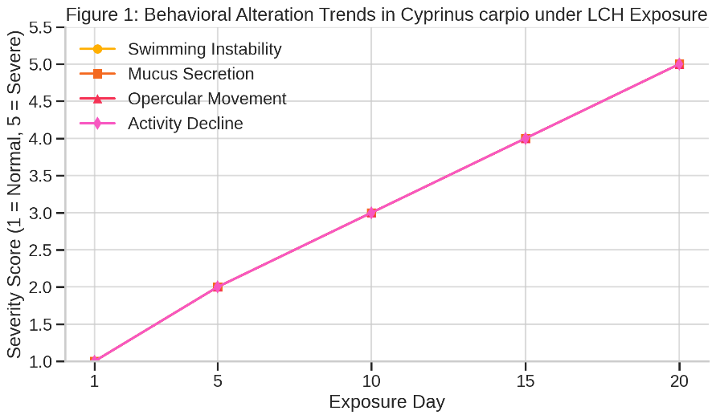

**Figure 1. Behavioral Deviation Intensity Across Exposure Days**

Figure 1 illustrates the progressive behavioral alterations in *Cyprinus carpio* over a 20-day sublethal exposure to lambda-cyhalothrin. Observable symptoms such as erratic swimming, increased mucus secretion, irregular opercular movements, and declining activity levels intensified with duration, indicating early neurotoxic effects and systemic stress triggered by prolonged pesticide exposure.

**3.2 Biochemical Toxicity**

The liver tissue displayed a steady decline in protein metabolism through all three protein categories: total, soluble and structural proteins decreased substantially throughout the time period. The stress conditions led to increased protease activity and free amino acid levels which confirmed enhanced proteolytic breakdown according to Table 2. The biochemical analysis confirmed that LCH activates energy stress responses through protein breakdown into amino acids which activates survival mechanisms based on catabolism (Figure 2).

**Table 2. Protein and Enzymatic Alterations in Liver Tissue**

|  |  |  |  |  |  |
| --- | --- | --- | --- | --- | --- |
| **Exposure Day** | **Soluble Protein (mg/g)** | **Structural Protein (mg/g)** | **Total Protein (mg/g)** | **Protease Activity (U/mg)** | **Free Amino Acids (µmol/g)** |
| 1 | 99.22 | 88.05 | 187.27 | 10.3 | 4.7 |
| 5 | 90.27 | 86.88 | 177.15 | 10.5 | 5.4 |
| 10 | 76.05 | 80.55 | 156.60 | 13.9 | 5.9 |
| 15 | 72.67 | 76.72 | 149.39 | 14.2 | 6.6 |
| 20 | 60.86 | 67.62 | 128.48 | 14.6 | 7.8 |

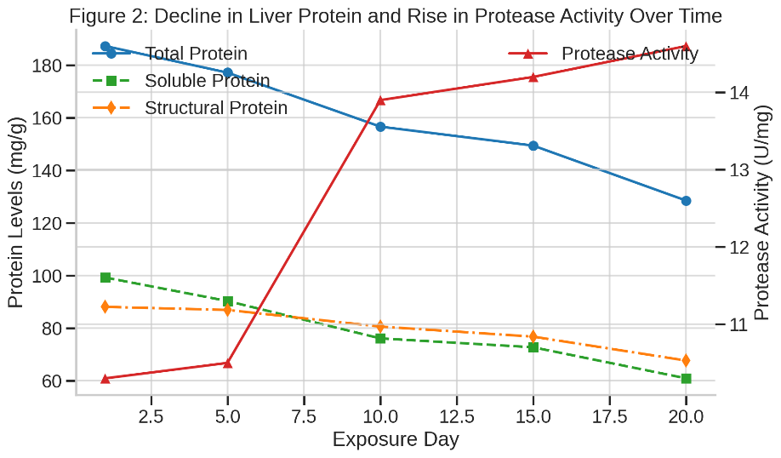

**Figure 2. Decline in Liver Protein and Rise in Protease Activity Over Time**

Figure 2 shows a time-dependent decline in total, soluble, and structural protein levels in the liver of *Cyprinus carpio*, alongside a rise in protease activity. This trend indicates enhanced proteolysis and metabolic stress due to lambda-cyhalothrin exposure, reflecting the fish's physiological shift toward energy compensation under toxic conditions.

**3.3 Oxidative and Antioxidant Enzyme Alterations**

The types of LCH exposure below lethal levels increased the MDA content in fish tissue while simultaneously decreasing the activity of CAT and SOD along with GPx and GST enzyme systems thus demonstrating oxidative stress (Table 3). The elevated MDA levels demonstrate membrane lipid peroxidation at the same time as reduced enzymatic activity shows a breakdown of antioxidant protection (Figure 3).

**Table 3. Oxidative Stress Biomarkers**

|  |  |  |  |  |  |
| --- | --- | --- | --- | --- | --- |
| **Exposure Day** | **MDA (nmol/mg)** | **CAT (U/mg)** | **SOD (U/mg)** | **GPx (U/mg)** | **GST (U/mg)** |
| 1 | 1.1 | 5.6 | 3.8 | 1.2 | 2.3 |
| 5 | 1.5 | 4.7 | 3.2 | 1.0 | 1.8 |
| 10 | 1.9 | 4.1 | 2.7 | 0.8 | 1.4 |
| 15 | 2.3 | 3.2 | 2.3 | 0.7 | 1.2 |
| 20 | 2.9 | 2.5 | 1.9 | 0.6 | 1.0 |

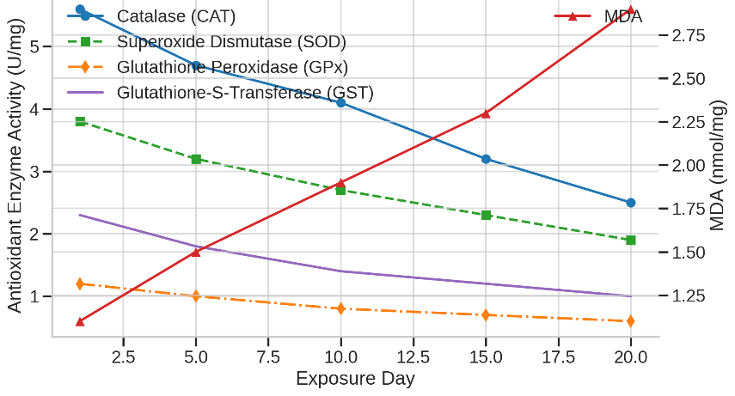

**Figure 3. Antioxidant Enzyme Suppression vs MDA Rise**

Figure 3 depicts a marked suppression of antioxidant enzymes (CAT, SOD, GPx, GST) and a concurrent rise in malondialdehyde (MDA) levels in *Cyprinus carpio* over 20 days of lambda-cyhalothrin exposure. This trend highlights increasing oxidative stress and cellular damage, indicating compromised antioxidant defense mechanisms during prolonged sublethal toxicity.

**3.4 Ionic and ATPase Alterations**

The gill tissues experienced substantial changes in ionic homeostasis as Na⁺, K⁺ and Ca²⁺ concentrations decreased throughout the tissue. The essential ATPase enzymes which support ion transport activities demonstrated parallel decreases according to Table 4. The alterations in enzymatic activity demonstrate problems with osmoregulation and energy-based ion regulation (Figure 4).

**Table 4. ATPase Activity in Gill Tissue**

|  |  |  |  |
| --- | --- | --- | --- |
| **Exposure Day** | **Na⁺/K⁺ ATPase (µM Pi/mg/hr)** | **Ca²⁺ ATPase (µM Pi/mg/hr)** | **Mg²⁺ ATPase (µM Pi/mg/hr)** |
| 1 | 2.10 | 1.60 | 1.90 |
| 5 | 1.94 | 1.10 | 1.67 |
| 10 | 1.79 | 0.88 | 1.49 |
| 15 | 1.80 | 1.06 | 1.43 |
| 20 | 1.85 | 1.18 | 1.24 |

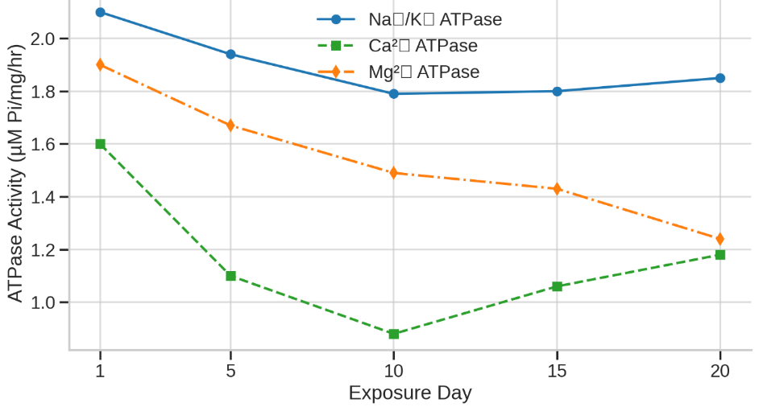

**Figure 4. Trends in ATPase Enzyme Activities Across Exposure Days**

Figure 4 illustrates the declining activity of Na⁺/K⁺, Ca²⁺, and Mg²⁺ ATPase enzymes in the gill tissues of *Cyprinus carpio* during prolonged lambda-cyhalothrin exposure. The reduction in ATPase activity reflects impaired ion transport and osmoregulation, with slight recovery observed at later stages, suggesting partial physiological adaptation to stress.

**3.5 Reproductive Toxicity**

The analysis showed both Gonado-somatic index (GSI) and sex hormone levels reached extremely low levels. The microscopic examination showed ovarian follicles were degenerating while testicular sperm production decreased (Table 5). The research indicates that LCH exposure creates enduring reproductive threats for freshwater fish communities (Figure 5).

**Table 5. Reproductive Hormone Levels and GSI**

|  |  |  |  |  |
| --- | --- | --- | --- | --- |
| **Exposure Day** | **Testosterone (ng/mL)** | **Estradiol (pg/mL)** | **11-Ketotestosterone (ng/mL)** | **GSI (%)** |
| 1 | 4.3 | 98 | 2.7 | 4.8 |
| 5 | 3.8 | 84 | 2.3 | 4.1 |
| 10 | 3.0 | 66 | 1.7 | 3.5 |
| 15 | 2.2 | 49 | 1.2 | 2.9 |
| 20 | 1.5 | 33 | 0.7 | 2.1 |

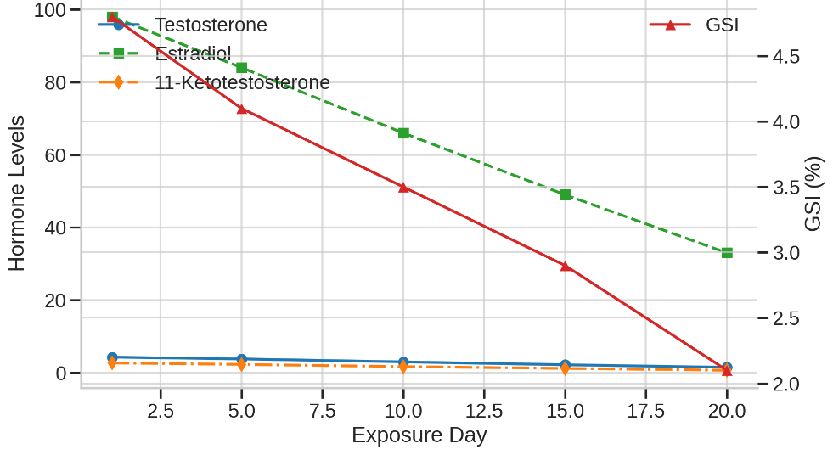

**Figure 5. Decline in GSI and Sex Hormones Over Time**

Figure 5 illustrates the progressive decline in the gonado-somatic index (GSI) and circulating sex hormones—testosterone, oestradiol, and 11-ketotestosterone—in *Cyprinus carpio* over a 20-day exposure to lambda-cyhalothrin. The data reflect endocrine disruption and impaired reproductive function, intensifying with exposure duration, highlighting the pesticide’s reproductive toxicity.

**3.6 Haematological Indices**

The blood profiles underwent significant changes after exposure to sublethal LCH levels. The blood analysis showed decreased RBC, Hb, and PCV levels together with increased WBC numbers which indicated anemia and immune activation (Table 6). The reduction of red cell indices and haemoglobin levels demonstrates that LCH causes anemia (Figure 6).

**Table 6. Haematological Parameters in *C. carpio***

|  |  |  |  |  |  |  |  |
| --- | --- | --- | --- | --- | --- | --- | --- |
| **Day** | **RBC (×10⁶/mm³)** | **Hb (g/dL)** | **PCV (%)** | **WBC (×10³/mm³)** | **MCV (fL)** | **MCH (pg)** | **MCHC (g/dL)** |
| 1 | 2.80 | 9.4 | 38 | 7.2 | 135 | 33.5 | 25.0 |
| 5 | 2.35 | 8.2 | 32 | 8.6 | 136 | 34.9 | 24.0 |
| 10 | 2.10 | 7.5 | 29 | 9.4 | 138 | 35.7 | 23.5 |
| 15 | 1.89 | 6.8 | 26 | 10.5 | 137 | 36.0 | 23.0 |
| 20 | 1.65 | 6.1 | 23 | 11.8 | 140 | 37.0 | 22.5 |

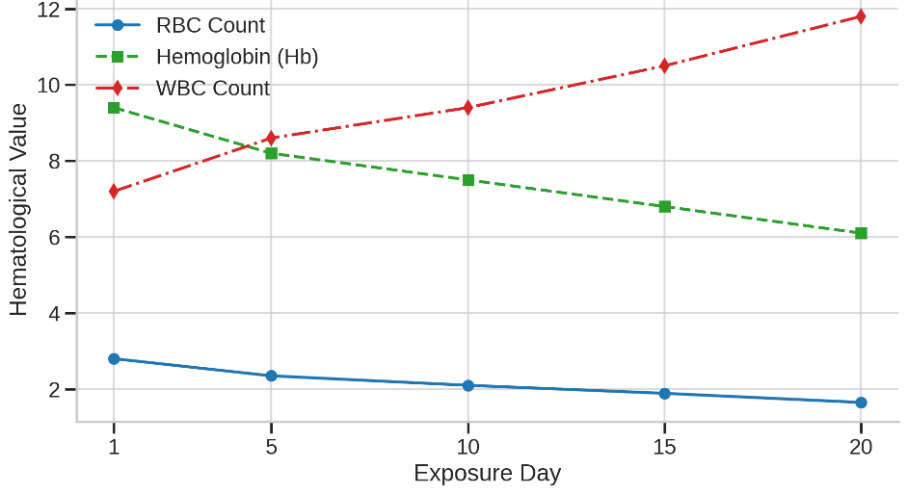

**Figure 6. Alteration in RBC, Hb, and WBC Counts**

Figure 6 displays significant alterations in haematological parameters of *Cyprinus carpio* following lambda-cyhalothrin exposure. Reductions in RBC count and hemoglobin levels, alongside increased WBC counts, indicate anemia and immunological stress. These changes reflect systemic toxicity, reduced oxygen transport capacity, and an activated immune response under prolonged sublethal pesticide exposure.

**4. Discussion**

The current study showed that Cyprinus carpio experienced deep toxicological consequences from sublethal lambda-cyhalothrin (LCH) exposure through biochemical and enzymatic and oxidative and ionic and reproductive and histological and hematological assessments. The research showed that longer exposure times to sublethal concentrations of LCH caused increasing physiological damage (Stanley et al., 2016; Dey & Saha, 2014). The study revealed that liver protein content decreased substantially while protease activity increased and free amino acids accumulated which indicates catabolic stress triggers an energy compensation mechanism (Ullah & Zorriehzahra, 2015; Bhavan et al., 2015). Acetylcholinesterase activity inhibition together with elevated acetylcholine levels confirmed neurological dysfunction which correlated with behavioral anomalies (Hernández-Moreno et al., 2010; Chaâbane et al., 2017). The observed increase in MDA levels together with the depletion of antioxidant enzymes CAT, SOD, GPx and GST demonstrated both antioxidant defense system failure and continuous cellular damage (Xing et al., 2012; Köprücü et al., 2010). The molecular changes were supported by histopathological findings that showed gill lamellar degeneration and liver hepatocyte necrosis and kidney glomerular disruption and tissue deterioration in intestines and gonads (Elbialy et al., 2015; El-Gerbed, 2014).

The reduction of ionic levels in gill, liver and muscle tissues together with decreased ATPase enzyme activities demonstrated both ionic imbalance and impaired osmoregulatory capacity (Kartheek & David, 2016; Mani & Sadiq, 2014). The prolonged exposure led to minor ATPase activity recovery but this recovery failed to restore the initial physiological disturbances because of restricted adaptive capacity (Chaâbane et al., 2017). The endocrine disruption and impaired fertility potential became evident through gonado-somatic index decline and reproductive hormone level reduction along with gonadal tissue histological changes (Yekeen et al., 2016). The results of hematological analysis showed a continuous decrease in RBC, Hb, and PCV levels which indicated anemia and simultaneously showed WBC count increases that suggested immune system activation under toxic stress (Khan et al., 2012; Ural, 2013). The research findings demonstrate known sublethal effects of pyrethroids through their unique ability to show how multiple organ systems fail simultaneously over time (Srivastava et al., 2016; Qureshi et al., 2016). The research demonstrates that sublethal LCH concentrations create significant health risks for aquatic populations because they reduce fish survival rates and lower reproductive success and weaken immune defenses in contaminated aquatic environments. The research limitations included controlled laboratory conditions and no assessment of recovery following exposure termination and no evaluation of combined effects with other environmental pollutants (Mani et al., 2017; Nwani et al., 2016). Future research needs to examine recovery patterns and multi-generational impacts and conduct field-based toxicological tests to guide actual policy decisions. The research demonstrates the immediate necessity for enhanced regulatory control and safer farming practices to safeguard freshwater biodiversity from enduring sublethal pesticide exposure.

**5. Conclusion**

The research demonstrates that Cyprinus carpio experiences major physiological and biochemical and cellular disturbances when exposed to lambda-cyhalothrin at levels below the acute toxicity threshold. The investigation adopted a systematic time-based method that showed LCH exposure injures fundamental metabolic functions while interrupting enzymatic processes and ion control and starting an oxidative stress response which destabilizes homeostasis. Behavioural changes along with acetylcholinesterase inhibition indicate neurotoxic symptoms yet the decrease of antioxidant defenses and higher lipid damage demonstrates increased cellular sensitivity. The compound demonstrates strong reproductive toxicity through its effects on gonado-somatic index and hormone levels and gonadal histoarchitecture. The observed haematological changes demonstrated that the compound affected both immune and oxygen transport system functions throughout the body. The research demonstrates that LCH creates widespread stress throughout fish systems which threatens their health and reproductive outcomes and endangers population survival. The validity of C. carpio as a bioindicator for aquatic toxicology research is established while researchers demonstrate that pesticide contamination in freshwater systems creates broader ecological questions. The study delivers extensive data but future research demands additional studies about recovery after exposure together with examinations of pollutants interactions as well as aquatic ecosystem consequences during extended periods. The increasing agricultural application of pyrethroids supports regulatory interventions and sustainable management practices together with active environmental toxicological monitoring to protect freshwater biodiversity and overall natural health.

**REFERENCES**

1. Stanley, J., Preetha, G., Stanley, J., & Preetha, G. (2016). Pesticide toxicity to fishes: exposure, toxicity and risk assessment methodologies. *Pesticide Toxicity to Non-target Organisms: Exposure, Toxicity and Risk Assessment Methodologies*, 411-497.
2. Sabra, F. S., & Mehana, E. S. E. D. (2015). Pesticides toxicity in fish with particular reference to insecticides. *Asian Journal of Agriculture and Food Sciences*, *3*(1).
3. Ullah, S., & Zorriehzahra, M. J. (2015). Ecotoxicology: a review of pesticides induced toxicity in fish. *Advances in Animal and Veterinary Sciences*, *3*(1), 40-57.
4. Dey, C., & Saha, S. K. (2014). A comparative study on the acute toxicity bioassay of dimethoate and lambda-cyhalothrin and effects on thyroid hormones of freshwater teleost fish Labeo rohita (Hamilton). *International journal of environmental research*, *8*(4), 1085-1092.
5. Ullah, R., Zuberi, A., Ullah, S., Ullah, I., & Dawar, F. U. (2014). Cypermethrin induced behavioral and biochemical changes in mahseer, Tor putitora. *The Journal of toxicological sciences*, *39*(6), 829-836.
6. Bhavan, P. S., Srinivasan, V., Satgurunathan, T., & Deepthi, P. (2015). Lethal and sub-lethal toxic effects of a pyrethroid insecticide, λ-cyhalothrin on activities of acetylcholinesterase, glutamic oxaloacetic transaminase, glutamic pyruvic transaminase and catalase in the post-larvae of the prawn Macrobrachium rosenbergii. *Advances in Bioresearch*, *6*(5).
7. Srivastava, P., Singh, A., & Pandey, A. K. (2016). Pesticides toxicity in fishes: biochemical, physiological and genotoxic aspects. *Biochemical and cellular archives*, *16*(2), 199-218.
8. Köprücü, K., Yonar, S. M., & Şeker, E. (2010). Effects of cypermethrin on antioxidant status, oxidative stress biomarkers, behavior, and mortality in the freshwater mussel Unio elongatulus eucirrus. *Fisheries science*, *76*, 1007-1013.
9. Banaee, M. (2013). Physiological dysfunction in fish after insecticides exposure. In *Insecticides-Development of safer and more effective technologies*. IntechOpen.
10. Sana Ullah, S. U., & Zorriehzahra, M. J. (2015). Ecotoxicology: a review of pesticides induced toxicity in fish.
11. Elbialy, Z. I., Ismail, T., Abdelhady, D. H., & El-Asely, A. M. (2015). Assessment of Genotoxic Effects of Pesticide Residues and Related Haemato-Biochemical Parameters on Farmed Nile Tilapia (Oreochromis Niloticus L.) in Kafrelsheikh Governorate, Egypt. *Alexandria Journal of Veterinary Sciences*, *44*(1).
12. Kartheek, R., & David, M. (2016). Fipronil induced modulations in biochemical and histopathological aspects of male Wistar albino rats: a subchronic study. *World*, *5*(2), 26-32.
13. Chaâbane, M., Ghorbel, I., Elwej, A., Mnif, H., Boudawara, T., Chaâbouni, S. E., ... & Soudani, N. (2017). Penconazole alters redox status, cholinergic function, and membrane-bound ATPases in the cerebrum and cerebellum of adult rats. *Human & experimental toxicology*, *36*(8), 854-866.
14. Khan, A., Ahmad, L., & Khan, M. Z. (2012). Hemato-Biochemical Changes Induced by Pyrethroid Insecticides in Avian, Fish and Mammalian Species. *International journal of agriculture & biology*, *14*(5).
15. Hernández-Moreno, D., Soler, F., Míguez, M. P., & Pérez-López, M. (2010). Brain acetylcholinesterase, malondialdehyde and reduced glutathione as biomarkers of continuous exposure of tench, Tinca tinca, to carbofuran or deltamethrin. *Science of the Total Environment*, *408*(21), 4976-4983.
16. Yekeen, T. A., Fawole, O. O., Bakare, A. A., & Emikpe, B. O. (2016). Alteration in haematological, biochemical and reproductive indices of Rattus norvegicus treated with lambdacyhalothrin. *Zoology and Ecology*, *26*(1), 47-56.
17. Mani, V. M., Gokulakrishnan, A., & Sadiq, A. M. (2017). Molecular mechanism of Neu-rodevelopmental toxicity risks of Occupational exposure of Pyrethroid Pesticide with reference to Deltamethrin-A critical review. *BAOJ Pathology*, *1*(008).
18. El-Gerbed, M. S. (2014). Protective effect of lycopene on deltamethrin-induced histological and ultrastructural changes in kidney tissue of rats. *Toxicology and industrial health*, *30*(2), 160-173.
19. Qayoom, I., Balkhi, M. H., Mukhtar, M., Bhat, F. A., & Shah, F. A. (2014). Biochemical toxicity of organophosphate compounds in fishes. *SKUAST Journal of Research*, *16*(1), 1-13.
20. Mani, V. M., & Sadiq, A. M. M. (2014). Naringin modulates the impairment of memory, anxiety, locomotor, and emotionality behaviors in rats exposed to deltamethrin; a possible mechanism association with oxidative stress, acetylcholinesterase and ATPase. *Biomedicine & Preventive Nutrition*, *4*(4), 527-533.
21. Oliveira, C. A. V. (2010). *Behavioural Alterations and Biomarker Responses of Palaemon Serratus Exposed to Pesticides* (Master's thesis, Universidade de Aveiro (Portugal)).
22. Nwani, C. D., Agrawal, N. D., Raghuvanshi, S., Jaswal, A., Shrivastava, S., Sinha, N., ... & Shukla, S. (2016). Toxicological effects of carbosulfan in rats: Antioxidant, enzymological, biochemical, and hematological responses. *Toxicology and industrial health*, *32*(7), 1335-1343.
23. Xing, H., Li, S., Wang, Z., Gao, X., Xu, S., & Wang, X. (2012). Oxidative stress response and histopathological changes due to atrazine and chlorpyrifos exposure in common carp. *Pesticide biochemistry and physiology*, *103*(1), 74-80.
24. Qureshi, I. Z., Bibi, A., Shahid, S., & Ghazanfar, M. (2016). Exposure to sub-acute doses of fipronil and buprofezin in combination or alone induces biochemical, hematological, histopathological and genotoxic damage in common carp (Cyprinus carpio L.). *Aquatic toxicology*, *179*, 103-114.
25. Ural, M. Ş. (2013). Chlorpyrifos-induced changes in oxidant/antioxidant status and haematological parameters of Cyprinus carpio carpio: ameliorative effect of lycopene. *Chemosphere*, *90*(7), 2059-2064.